Project Development - Database design

## **Today class Agenda:**

1. Download and Install the MySQL
2. Working with MySQL Workbench
3. Queries of MySQL

## Introduction to Database:

1. When you take photo and upload to your account facebook so that your photo gonna store on Gallery, Gallery is a database
2. When you try to browse e-commerce websites it will show the list of products based on the inputs from the user. It means the data is coming from somewhere else is again a database

It means the database present in every corner of the digital world. A database is merely a structured collection of data which can used for searching and optimize the data

## Relational Database:

1. A data relating to each other by nature
2. Assume that e-Commerce websites have products which belong to the product category and associated with multiple tags.
3. Majority of the relational database the data will be stores in the Table format which consists of rows and columns
4. We have other objects which can provide security for the data like procedures, functions and triggers...

## SQL - Structured Query Language

1. Data Definition Language (DDL)
2. Data Manipulation Language (DML)
3. Data Control Language (DCL)

## Data Definition Language:

Data definition Language includes the statements that helps us to create the database objects like Tables, Views, Procedures and Functions

## Data Manipulation Language

Data Manipulation Language contains the statements that allows you to update and query data

## Data Control Language

Data control Language allows you to grant the permission to a user

# Download and Install the MySQL

Link for download: <https://dev.mysql.com/downloads/>

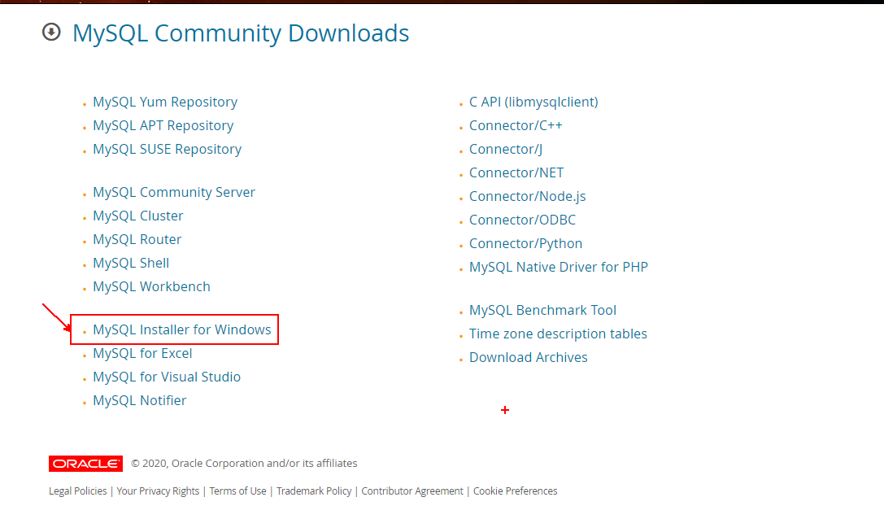

Open the Download software

